**NEA Scout Coarse Sun Sensor EDU Test Report**

D. Bullock

Department of Electrical Engineering, Arkansas Tech University, Russellville, AR, 72801

D. Edberg

Aerospace Engineering Department, California State Polytechnic University, Pomona, CA, 91768

A. Heaton

NASA Marshall Space Flight Center, Huntsville, AL, 35812

C. Becker

NASA Marshall Space Flight Center, Huntsville, AL, 35812

**Sun Sensor Test Setup**

The NEA Scout utilizes three sun sensor modules composed of four Hamamatsu S7686 Si photodiodes that are sensitive in the visible spectrum from 480 nm to 660 nm with the peak sensitivity occurring at 550 nm. The four photodiodes are each mounted at angles of 25° from vertical and produce an electrical current when light containing wavelengths within the photodiode’s spectral response range strikes its face.

The sun sensor module was tested using a sun simulator that incorporated a 500 W mercury bulb. The sun simulator was mounted on a tripod that allowed for adjustments of height, vertical angle, and azimuthal angle. Additionally, the light intensity was adjusted by connecting the simulator to a variable autotransformer. The sun simulator was configured to measure the performance of the sun sensor array at 0°, 45°, and 90° from vertical. At each vertical position the intensity of the sun simulator was adjusted to mimic the sun light intensity at one Astronomical Unit by measuring the optical power at the face of the photodiode array with a Thor Labs PM100D optical power meter connected to an S130C optical sensor. The sensor is sensitive to wavelengths from 400 nm – 1100 nm, similar to the optical sensitivity of the Si photodiodes.

The sun sensor array was mounted on a 3D printed replica the portion of the NEA Scout body where the sun sensor is to be mounted. To mimic the reflectance of the aluminum body of the CubeSat, the 3D printed replica piece was wrapped with household aluminum foil. The entire assembly was then mounted on a rotation table that allowed for 360° azimuthal rotation. For each sun simulator angle (0°, 45°, and 90° from vertical), the sun sensor data was taken for azimuthal angles from 0° to 180° in 10° increments. The experimental setup is shown schematically in Figure 1.

The electronics on the NEA Scout convert the currents produced by each photodiode into a count that is proportional to the current. To mimic the flight electronics, a circuit was built that converts the current into a voltage using a trans-impedance amplifier (TIA). The TIA is an operational-amplifier (op-amp) based inverting amplifier. In this application each photodiode’s cathode (negative terminal) is connected to the inverting input of an LM324 op-amp (the non-inverting input is grounded). A feedback resistor is connected between the output of the LM324 and the inverting input. This feedback controls the gain of the amplifier. The value of the feedback resistor (22 kΩ) was chosen such that at maximum intensity the voltage output would be below the saturation levels (+5 VDC) of the amplifier. The output voltage is equal to the product of the photodiode current and the feedback resistor.

**Figure 1. Illustration of the experimental setup. Data are taken by rotating the azimuthal angle from 0° to 180° in 10° increments for three different sun simulator angles (0°, 45°, and 90°). The currents generated in the photodiodes are then connected to trans-impedance amplifiers (TIAs) that produce an output voltage proportional to the input currents. The output voltages are then connected to a four channel, 16-bit analog to digital converter that are then sent to a microcontroller on the I2C bus. The microcontroller is then interfaced with a PC to capture the data.**

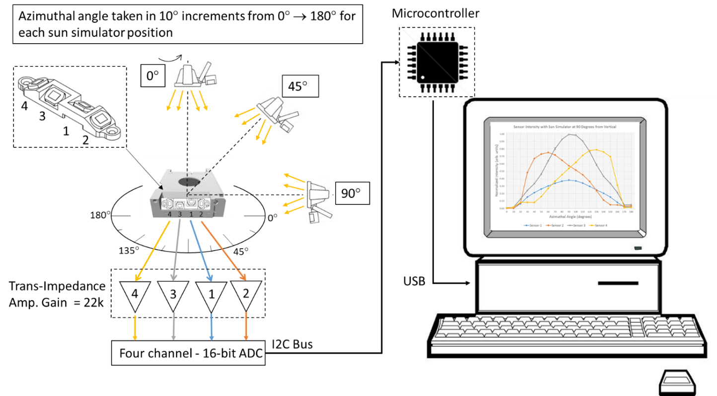

The output voltage from each photodiode is connected to a four channel, 16-bit analog to digital converter (ADC). In this experiment, the ADS1115 was chosen as the ADC. The ADC was powered with +5 VDC which resulted in a 0.125 mV per bit resolution [4]. The ADC was then connected to a microcontroller using the I2C bus. The microcontroller also configured to communicate with a PC using USB port. Data was collected at a rate of 1 Hz. For each angle, 10-20 data points were taken for each of the four photodiodes in the sun sensor array. The data was then averaged, normalized, and plotted.

.

**Sun Sensor Test Results**

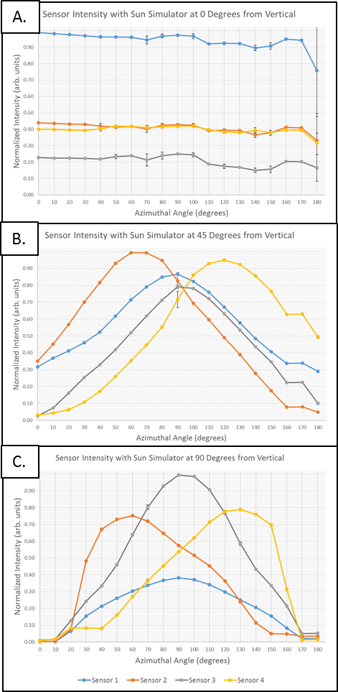

**Figure 2 Normalized sun sensor data for vertical sun simulator angles of 0° (A), 45° (B), and 90° (C).**

Figures 2A, 2B, and 2C show the results from the sun sensor tests with the simulator at 0°, 45°, and 90° from vertical respectively.

In Figure 2A the sun simulator was placed directly above the sun sensor assembly. Photodiode sensor 1 shows the strongest signal followed by sensors 2 and 4 that have roughly the same signal intensity, and signal 3 that has the lowest intensity. As expected, the relative intensity levels remain fairly constant as the sensor is rotated through the different azimuthal angles. However, the signal intensity for all for sensors rapidly decreases at the 180° data point. This is attributed to a slight misalignment error in mounting the sun sensor to the rotational table.

Figure 2B shows the data with the sun simulator at 45° from vertical. These data show that sensors 2 and 4 have the highest relative intensities at 60° and 120° respectively. Also, sensors 1 and 3 reach their maximum values at the same azimuthal angle of 90°.

In figure 2C, sensors 1 and 3 reach their relative maxima at the same azimuthal angle of 90°, while sensors 2 and 4 reach their maxima at 60° and 130° respectively.